1. PRODUCT NAME
Touch ‘n Seal® Quick Cure HY (High Yield) Polyurethane Foam Sealant

Touch ‘n Seal® Quick Cure RX (Reduced Expansion) Polyurethane Foam Sealant

2. MANUFACTURER
Convenience Products
866 Horan Dr., Fenton, MO 63026 USA
(636) 349-5855
(800) 325-6180
FAX (636) 349-5335
E-mail support@touch-n-seal.com
Website: www.touch-n-seal.com

3. PRODUCT DESCRIPTION
Touch ‘n Seal Quick Cure foams are high performance, single component, moisture curing, Class 1 fire retardant, expanding polyurethane sealants. Quick Cure sealants are available in both straw dispensed aerosol cans and larger cylinders with hoses and applicators.

Quick Cure sealants are available in High Yield (HY) and Reduced Expansion (RX) formulations. Use Quick Cure HY when high expansion is needed to fill and seal larger gaps and cracks. Use Quick Cure RX when requiring controlled dispensing rate and less post expansion. Both formulations are tack free in 30 minutes or less, can be trimmed in 1 hour and are fully cured in about 24 hours, depending upon humidity and temperature.

Basic Use
Use Quick Cure Polyurethane Foam Sealants to permanently air seal and insulate gaps and cracks to block drafts, moisture and insects while improving comfort and reducing energy usage in commercial, industrial, agricultural and residential applications. Use to seal around plumbing, ventilation outlets, electrical junctions, between sill plates and concrete slabs, or anywhere you need a fast, economical air-sealing moisture barrier.

For fireblock and sealing applications refer to ICC-ES ESR 1926 detail.

Quick Cure foams provide permanent insulating and air sealing solutions to building component materials including wood, masonry, insulating foam boards, metal, wire insulation, plastics and sheetrock.

Use Touch ‘n Seal Poly-Clean Foam Cleaner to clean wet Quick Cure foams from hands, tools and foam applicator guns.

Composition & Materials
Touch ‘n Seal Quick Cure polyurethane one-component expanding foam sealants are permanent, hypoallergenic and dry within minutes of application. Quick Cure foams are non-toxic and will not decompose with age.

Sizes
HY Straw Foam - Item # 4004001212
12 ounce (340 gm)
HY Straw Foam - Item # 4004001224
24 ounce (680 gm)

HY Foam Complete - Item # 4004518100
10 pounds (4.54 kg)

HY Foam Complete - Item # 4004518160
16 pounds (7.26 kg)

RX Foam Complete - Item # 4004510950
10 pounds (4.54 kg)

RX Foam Complete - Item # 4004516900
16 pounds (7.26 kg)

Features/Benefits
- Multiple package sizes
- Easy to use
- Class 1 fire retardant
- Provides a permanent seal against air, moisture and insect infiltration
- Easier to use than caulk type penetration sealants
- Bonds to common building materials including wood, concrete, insulating foam boards, metal, plastics and sheetrock
- Available in both straw and cylinder dispensing systems
- Reduces energy loss
- No ozone depleting chemicals
- Does not shrink
- Does not trap moisture, dust and allergens as does fiberglass insulation
- Expands to fill gaps and cracks, reducing air exchanges
- Reduces use of fossil fuels and improves air quality
- Helps to reduce Greenhouse Gas Emissions
- Closed cell structure

Limitations
- Foam is combustible. Do not expose to temperatures above 240°F (116°C), open flames or sparks
- Not for exposure to ultraviolet light
- Chemicals must be 50°-100°F (10°-38°C) prior to application
- Do not store in temperatures above 120°F (49°C)
- Always refer to local building code regulations
- Do not leave product exposed; cover with approved facings
- Propellant in 12 & 24 ounce straw foam is flammable; read MSDS and do not use near high heat, sparks or open flame
- Not a fire stop material

4. TECHNICAL DATA

Applicable Standards

ASTM E-84 Surface Burning Characteristics

ASTM E-96 Water Vapor Transmission

ASTM C-273 Shear Strength

ASTM C-273 Shear Strain

ASTM C-518 R-Value

ASTM E-814 Modified for Fire Block

ASTM C-1536 Yield

ASTM D-1621 Compressive Strength

ASTM D-1622 Core Density

ASTM D-1623 Tensile Strength

ASTM D-6226 Closed Cell Content

UL 1715 Fire Test

Approvals/Certifications/Listings
- ICC ES ESR-1926
- International Building Code
- International Residential Code
- BOCA National Building Code
- 1999 Standard Building Code
- California Bureau of Home Furnishings and Insulation
- Underwriters Laboratories Classified Caulking & Sealants

Shelf Life
12 months in unopened container when stored between 60°-90°F (16°-32°C), in a dry, well-ventilated area.

Storage & Disposal
Keep containers tightly closed in a cool, well-ventilated area. Ideal storage temperature is 60°-90°F (16°-32°C). Storage above 90°F (32°C) will reduce shelf life. Do not store at temperatures greater than 120°F (49°C). Avoid freezing. Do not expose containers to conditions that may damage, puncture, or burst the containers. Dispose of leftover material/containers in accordance with Federal, state and local regulations. See Material Safety Data Sheet for more information.

5. INSTALLATION/APPLICATION
Always refer to local building codes prior to application of Touch ‘n Seal foam sealants.

The Touch ‘n Seal® Quick Cure one-component expanding foam sealant can be applied to and will adhere to almost any traditional construct surfaces including wood, masonry, insulating foam boards, metal, plastics and sheetrock.

Surfaces to receive Touch ‘n Seal foam sealants must be dry, clean and free of dust, dirt, grease and other substances that may inhibit proper adhesion. For best results apply Touch ‘n Seal® Quick Cure expanding foam sealant when surface and ambient temperatures are between 60°-100°F (16°-38°C). Temperature of chemical contents must be between 50°F-100°F (10°C-38°C) before dispensing.

Use all chemical contents within 30 days of initial dispensing.

Keep out of reach of children. Always wear proper personal protective equipment, including gloves, clothing and eyewear. Use in well-ventilated area.

Please refer to manufacturer’s instructions or request a faxed set of instructions from Convenience Products by calling Customer Service at 800-325-6180.
6. AVAILABILITY & COST
Availability
Touch ‘n Seal polyurethane foams are available throughout the U.S., Canada, Mexico and the world. Contact Convenience Products Customer Service at 800-325-6180 or FAX 636-349-1708 for distributor information.

Cost
Contact Convenience Products for local distributors who can provide cost and delivery information.

7. WARRANTY
Convenience Products warrants its Touch ‘n Seal products to be free of defects in workmanship and function.

Convenience Products is not liable for any incidental, consequential or any other damages beyond the description herein, however, certain states have specific laws regarding limitation on incidental or consequential damages, in which case, and you may have other legal rights.
8. MAINTENANCE
None

9. TECHNICAL SERVICES
Technical assistance, including more detailed information, product literature, test results, assistance with preparing project specifications

and application training is available by contacting Convenience Products.

10. FILING SYSTEMS
Additional information is available from the manufacturer upon request.

The information contained herein was accurate at the time of publishing. Please refer to the Touch ‘N Seal website for the latest information.

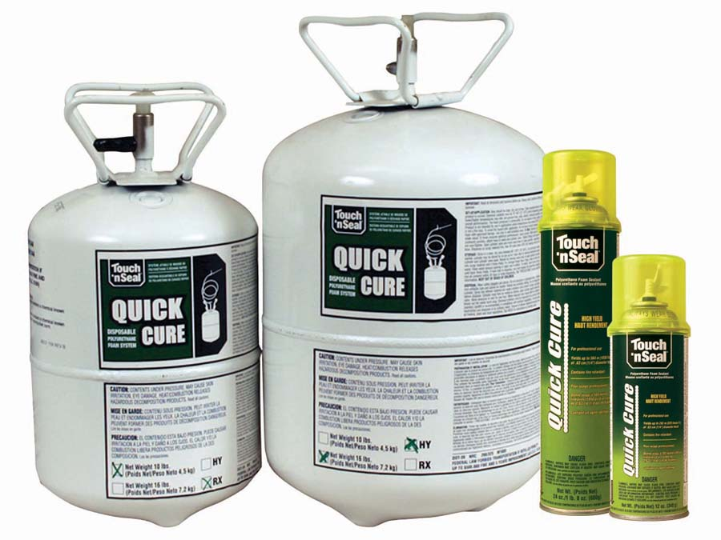

TYPICAL PROPERTIES OF TOUCH ‘N SEAL QUICK CURE POLYURETHANE CLASS 1 FOAM SEALANT
Container Sizes | 12 & 24 ounce (340 & 680 gm) Straw Foam |  | 10 & 16 pound (4.54 & 7.26 kg) Cylinder Foam
Shelf Life | 1 year; unopened container |  | 1 year; unopened container
Surface Dry Time/Surface Tack Free Time | < 30 minutes @ 72˚F/ 50% R.H. |  | < 15 minutes @ 72˚F/50% R.H.
Fully Cured | 24 hours @ 72˚F/ 50% R.H. |  | 24 hours @ 72˚F/ 50% R.H.
Trimmable | < 1 hour @ 72˚F/ 50% R.H. |  | < 1 hour @ 72˚F/ 50% R.H.
ASTM E-84 Surface Burning Characteristics  Flame Spread  Smoke Development | 10  15 |  | 20  25
ASTM E-96 Water Vapor Transmission | 10 perm inches (25mm) |  | 3.3 perm inch
ASTM C-273 Shear Strength | N/A |  | 18 psi (1.27 kg/cm²)
ASTM C-273 Shear Strain | N/A |  | 57%
ASTM C-518 R-Value | 4 - 5 /in. (25 mm) |  | 4 - 5 /in. (25 mm)
ASTM E-814 Modified for Fire Block | Pass |  | Pass
ASTM C-1536 Yield | 12 oz (340gm)  ¼ in. (6.4mm) dia. bead – 900 ft. (280m)  3/8 in. (9.5mm) dia. bead – 400 ft. (124m) |  | 10 lb HY  ¼ in. (6.4mm) dia. bead – 15,300 ft. (4,663m)  3/8 in. (9.5mm) dia. bead – 6,800 ft. (2,072m)
ASTM C-1536 Yield |  |  | 16 lb HY  ¼ in. (6.4mm) dia. bead – 24,400 ft. (7,437m)  3/8 in. (9.5mm) dia. bead – 10,900 ft. (3,322m)
ASTM C-1536 Yield | 24 oz (680gm)  ¼ in. (6.4mm) dia. bead – 1,800 ft. (550m)  3/8 in. (9.5mm) dia. bead – 800 ft. (249m) |  | 10 lb RX  ¼ in. (6.4mm) dia. bead – 14,700 ft. (4,480m)  3/8 in. (9.5mm) dia. bead – 6,500 ft. (1,981m)
ASTM C-1536 Yield |  |  | 16 lb RX  ¼ in. (6.4mm) dia. bead – 24,080 ft. (7,340m)  3/8 in. (9.5mm) dia. bead – 10,500 ft. (3,200m)
ASTM D-1621 Compressive Strength |  |  | 11 psi (0.77 kg/cm²)
ASTM D-1622 Core Density | 1.75 +/- .25 pcf (20.8 +/1 4.0 kg/m³) |  | 1.3 – 1.8 pcf (20.8 – 28.8 kg/m³)
ASTM D-1623 Tensile Strength  Percent elongation at break | N/A |  | 33 psi (0.02 kg/cm²)  10%
UL 1715 Corner Room Fire Test | N/A |  | Pass - No thermal barrier required in Type V construction
ASTM D-6226 Closed Cell Content | N/A |  | 70%
International Building Code | Conforms |  | Conforms
International Residential Code | Conforms |  | Conforms
BOCA National Building | Conforms |  | Conforms
1999 Standard Building Code | Conforms |  | Conforms
ICC-ES | ESR-1926 |  | ESR-1926
California Bureau of Home Furnishings and Insulation | Listed |  | Listed
NPFA 30B Classification | Aerosol Level 2 |  | N/A
Underwriters Laboratories Classified Caulking & Sealants | UL | ULC | R14175
Underwriters Laboratories Classified Caulking & Sealants | R14175 | BLEZC.R14175 | R14175

